JV Portal – Earmarked Funds API
Integration guide for the JV Portal CAP developer
Backend: SAP S/4HANA DV1, client 230 — standard SAP API “Earmarked Funds Document (A2X)” (OData V4, service API_EARMARKEDFUNDSDOCUMENT), exposed via SAP Integration Suite.
Status: Tested end to end in DEV (create verified — documents 200000002 / 200000003).
Version: 1.0 • 13 Aug 2026 • Author: Ray

1. Endpoint
https://epf-ent-cf-ap11-prd.it-cpi004-rt.cfapps.ap11.hana.ondemand.com/http/earmarkedfunds
All calls go through this single endpoint; the path after /earmarkedfunds selects the resource.
- Authentication: OAuth 2.0 client credentials (token URL + client ID/secret from the Integration Suite service key — shared separately via secure channel). Send the token as Authorization: Bearer <token>.
- Client: always append ?sap-client=230 to GET calls. For POST the client is fixed inside the iFlow; including it does no harm.
- Allowed methods: GET and POST only — anything else returns 405.

2. Operations

2.1 Read — list documents
GET /earmarkedfunds/EarmarkedFundsDocument?sap-client=230&$top=50
Standard OData V4 query options are passed through: $filter, $top, $skip, $orderby, $select, $count, $expand=_EarmarkedFundsDocumentItem.
Example — documents for company code 1000:
GET /earmarkedfunds/EarmarkedFundsDocument?sap-client=230&$filter=CompanyCode eq '1000'&$top=50

2.2 Read — single document (with items)
GET /earmarkedfunds/EarmarkedFundsDocument/<DocumentNumber>?sap-client=230&$expand=_EarmarkedFundsDocumentItem

2.3 Read — items of a document
GET /earmarkedfunds/EarmarkedFundsDocument/<DocumentNumber>/_EarmarkedFundsDocumentItem?sap-client=230

2.4 Read — service metadata
GET /earmarkedfunds/$metadata?sap-client=230
Responses for all GET calls are plain OData V4 JSON, exactly as S/4 returns them.

2.5 Create — document with items (deep insert)
POST /earmarkedfunds/EarmarkedFundsDocument?sap-client=230
Content-Type: application/json
Request body — use exactly this structure and field order (see section 3):
{
"EarmarkedFundsDocumentCategory": "30",
"EarmarkedFundsDocumentType": "11",
"CompanyCode": "1000",
"DocumentDate": "2026-08-12",
"PostingDate": "2026-08-12",
"TransactionCurrency": "MYR",
"EarmarkedFundsHeaderText": "JV Portal reservation",
"_EarmarkedFundsDocumentItem": {
"EarmarkedFundsDocumentItem_Type": [
{
"CommitmentItem": "721005",
"DocumentItemText": "line 1 text",
"EmrkdFndsAmountInTransCrcy": 100.00,
"FundsCenter": "100010100",
"TransactionCurrency": "MYR"
}
]
}
}
Multiple items: add more objects to the EarmarkedFundsDocumentItem_Type array.
Success response: the created document including the generated EarmarkedFundsDocument number (10 digits, e.g. 200000003) and the created items. Store this number — it is the key for all later reads.

3. Create payload rules (important)
- Do NOT send key or computed fields: no EarmarkedFundsDocument (document number) and no EarmarkedFundsDocumentItem (item number) — S/4 generates both. Also omit created-by/created-on, open/consumed amounts, CompanyCodeCurrency and other computed fields. Reference: the -create schemas in the official API spec.
- Items are wrapped in EarmarkedFundsDocumentItem_Type inside _EarmarkedFundsDocumentItem — an integration-layer requirement; the raw SAP API uses a plain array instead.
- Keep the field order exactly as in the sample (header and item). The integration layer converts JSON to a schema-validated format where element order matters — emit properties in exactly this order.
- Amounts: send as JSON numbers (e.g. 100.00). TransactionCurrency is mandatory at both header and item level whenever an amount is sent.
- Category/type values: document category 30 / type 11 / company code 1000 are the DEV values for the JV Portal scenario — confirm final values with FM functional before UAT.
- Account assignment: only CommitmentItem + FundsCenter are required in the current DEV FM configuration; GLAccount, CostCenter, Fund etc. exist in the schema and may be supplied if the design requires.

4. Response format notes
- GET responses: plain OData V4 JSON (untouched passthrough).
- POST responses: converted by the integration layer, so the shape differs slightly from raw OData: the document is wrapped in EarmarkedFundsDocument_Type; items appear under _EarmarkedFundsDocumentItem.EarmarkedFundsDocumentItem_Type; booleans and numbers arrive as strings (“false”, “10.0”); null dates appear as { “@nil”: “true” }. Parse defensively — read the document number from EarmarkedFundsDocument_Type.EarmarkedFundsDocument.
- Errors: 405 {“error”:“Method not allowed”} • 502 {“error”:“S4 call failed”,“detail”:“…”} — technical failure or S/4 rejection; detail contains the SAP message, e.g. “(FMEF/007) Enter a document category”. Show or log the detail text; S/4 business validation errors surface through the same 502 wrapper.

5. Working example (verified in DEV)
The payload in section 2.5 with amount 10.00 and item text “e2e line 1” created document 200000003 in S/4 client 230 (visible in Manage Earmarked Funds / FMX3): item 1, MYR 10.00, commitment item 721005, funds center 100010100.

6. Reference
- Official API spec: SAP API Business Hub — Earmarked Funds Document (A2X), CE_API_EARMARKEDFUNDSDOCUMENT_0001
- Useful status fields for the portal UI (from GET): EarmarkedFundsIsApproved, EmrkdFndsIsBlockedAgainstUsage, EarmarkedFundsIsCompleted, and item-level EmrkdFndsOpenAmtInTransCrcy (remaining amount on the reservation).

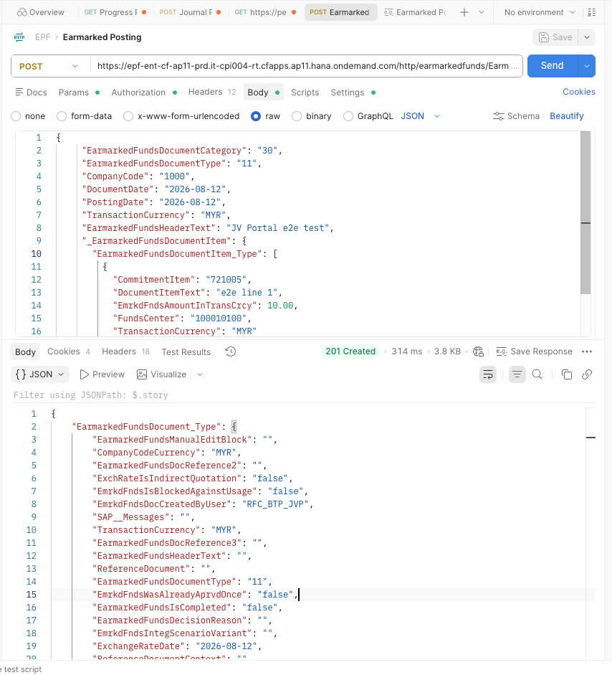

Sample response
{
"EarmarkedFundsDocument_Type": {
"EarmarkedFundsManualEditBlock": "",
"CompanyCodeCurrency": "MYR",
"EarmarkedFundsDocReference2": "",
"ExchRateIsIndirectQuotation": "false",
"EmrkdFndsIsBlockedAgainstUsage": "false",
"EmrkdFndsDocCreatedByUser": "RFC_BTP_JVP",
"SAP__Messages": "",
"TransactionCurrency": "MYR",
"EarmarkedFundsDocReference3": "",
"EarmarkedFundsHeaderText": "",
"ReferenceDocument": "",
"EarmarkedFundsDocumentType": "11",
"EmrkdFndsWasAlreadyAprvdOnce": "false",
"EarmarkedFundsIsCompleted": "false",
"EarmarkedFundsDecisionReason": "",
"EmrkdFndsIntegScenarioVariant": "",
"ExchangeRateDate": "2026-08-12",
"ReferenceDocumentContext": "",
"EarmarkedFundsDocEntryStatus": "",
"ReferenceDocumentLogicalSystem": "",
"_EarmarkedFundsDocumentItem": {
"EarmarkedFundsDocumentItem_Type": {
"PrdcssrFundsReservationDocItem": "0",
"Customer": "",
"EmrkdFndsAcctAssgmtChangeable": "false",
"USFedGovernmentUUID": {
"@nil": "true"
},
"EmrkdFndsItmToleranceLmtInPct": "0.0",
"FundsMgmtPeriodOfPerfStartDate": {
"@nil": "true"
},
"EmrkdFndsItmIsCompleted": "false",
"SAP__Messages": "",
"TransactionCurrency": "MYR",
"WBSElementExternalID": "",
"EmrkdFndsItmIsUnlimited": "false",
"FundedProgram": "",
"EmrkdFndsAmountInCCCrcy": "10.0",
"CommitmentItem": "721005",
"EmrkdFndsCnsmdAmtInCCCrcy": "0.0",
"FunctionalArea": "",
"BusinessArea": "",
"EmrkdFndsOpenAmtInCCCrcy": "10.0",
"PrdcssrFundsReservationDoc": "",
"EmrkdFndsCnsmdAmtInTransCrcy": "0.0",
"EmrkdFndsDocItmLastChgdByUsr": "",
"EmrkdFndsReferenceDocumentItem": "",
"DocumentItemText": "e2e line 1",
"EmrkdFndsItmIsApproved": "true",
"CompanyCodeCurrency": "MYR",
"Fund": "",
"EmrkdFndsOpenAmtInTransCrcy": "10.0",
"EmrkdFndsAmountInTransCrcy": "10.0",
"EmrkdFndsItmCnsmpnInCCCrcyOnly": "false",
"EmrkdFndsOverrideGlobTolerance": "false",
"CostCenter": "",
"EarmarkedFundsDocumentItem": "1",
"EmrkdFndsItmPrdcssrCompleted": "false",
"FundsCenter": "100010100",
"EmrkdFndsItmIsReceiver": "false",
"Supplier": "",
"PrdcssrFundsPreCmtmtDoc": "",
"DueDate": {
"@nil": "true"
},
"EmrkdFndsDocItmLastChangeDate": {
"@nil": "true"
},
"EmrkdFndsDocItmCreationDate": "2026-08-13",
"EmrkdFndsItmIsStatistical": "false",
"ProfitCenter": "",
"EarmarkedFundsDocument": "200000005",
"GLAccount": "",
"EmrkdFndsItmIsSender": "false",
"InternalOrder": "",
"EmrkdFndsItmIsBlkdAgainstUsage": "false",
"EmrkdFndsHasValueAdjustments": "false",
"USFedPromptPaytActExclude": "false",
"PostingDate": "2026-08-12",
"FundsMgmtPeriodOfPerfEndDate": {
"@nil": "true"
},
"EmrkdFndsDocItmCreatedByUser": "RFC_BTP_JVP",
"GrantID": "",
"BudgetPeriod": "",
"PrdcssrFundsPreCmtmtDocItem": "0",
"EmrkdFndsItmIsDeleted": "false",
"CompanyCode": "1000",
"EmrkdFndsItmManualEditBlock": ""
}
},
"EarmarkedFundsDocReference": "",
"AbsoluteExchangeRate": "1.0",
"EmrkdFndsDocLastChangedByUser": "",
"EmrkdFndsIntegrationScenario": "",
"EmrkdFndsDocCreationDate": "2026-08-13",
"EarmarkedFundsDocument": "200000005",
"EmrkdFndsHasNegativeAmounts": "false",
"EarmarkedFundsIsApproved": "true",
"EmrkdFndsDocLastChangeDate": {
"@nil": "true"
},
"EmrkdFndsHasValueAdjustments": "false",
"EarmarkedFundsStartWorkflow": "false",
"EmrkdFndsExtDocumentNumber": "200000005",
"PostingDate": "2026-08-12",
"EmrkdFndsDocLastChangeDateTime": "2026-08-13T03:11:41Z",
"ReferenceDocumentType": "",
"EarmarkedFundsDocumentCategory": "30",
"DocumentDate": "2026-08-12",
"CompanyCode": "1000"
}
}

